AAPA Communications Award Program Entry Classification: Video

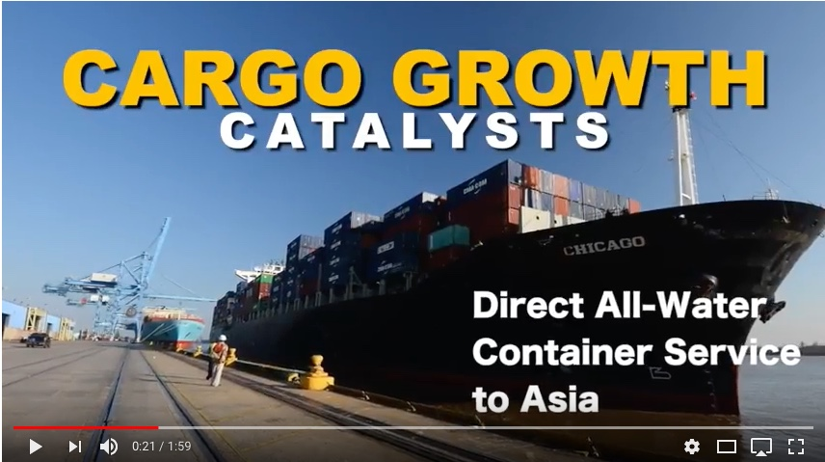
Port NOLA “Just Getting Started” Video

Summary — The Port of New Orleans Public Affairs team worked with a local video production firm to create a wow-factor video featuring a tightly edited combination of high-impact images, minimal yet purposeful text, and dynamic music to highlight recent Port successes.

You can watch the video here or see the mp4 attached.

1. What are/were the entry’s specific communications challenges or opportunities?
The 2017 State of the Port was scheduled for November 2017. It was to be the first state of the Port address for Brandy D. Christian who was named Port NOLA President & CEO just about year prior after the retirement of her predecessor who had steered the course for more than 15 years. All eyes were on the port to see how the new leadership might impact performance and operations. Much was accomplished in the year and there was much to talk about.
We wanted a powerful video that would be shown at the beginning of the programming to energize the audience and set a dynamic tone for Ms. Christian’s State of the Port. We also wanted to have an impactful collateral piece that could be used for at least the next six months across our communications channels to demonstrate the Port’s purposeful direction.
We had a short timeline to create this video and two others for State of the Port and a small budget—a month and half and $3,000 for all three videos.
2. How does the communication used in this entry complement the organization’s overall mission?
The Port of New Orleans mission is: To drive regional economic prosperity by maximizing the flow of international trade and commerce as a modern Gateway.
The “Just Getting Started” wow video features several of Port NOLA’s major successes across all four of its lines of business: cargo, rail, industrial real estate and cruise, to demonstrate to the industry audience that the Port is making gains with purpose and is positioning itself as a leading gateway with seamless integrated transportation solutions.
Key partnerships were also highlighted in the video. One of the main messages of the State of the Port was that a regional collaborative approach with local governments and economic development entities is absolutely critical in order for the Port to be able to provide the infrastructure needed to be a true modern gateway.
3. What were the communications planning and programming components used for this entry?
Goals:
- To set a dynamic tone for the 2017 State of the Port.
- To have an impactful collateral piece that could be used for at least the next six months across our communications channels to demonstrate the Port’s purposeful direction.
- To demonstrate to the industry audience that the Port is making gains and is positioning itself as a leading gateway with seamless integrated transportation solutions.
- To send a key message to regional audiences that the Port’s mission to drive a freight-based economic prosperity across our entire jurisdiction is gaining momentum.
- To demonstrate the integration of the New Orleans public Belt Railroad as the port’s newest line of business and demonstrate our position as a true integrated freight gateway.

Measurables: We would measure the success of this video by audience response at various presentations throughout the year. Also through social media engagement analytics.

Primary Audiences: Industry stakeholders - terminal operators, carriers, shippers, customers, potential customers, tenants, industry media, etc.
Secondary Audiences: Economic Development stakeholders – economic developments organizations, state legislators, local governments, community members, local media.
4. What actions were taken and what communication outputs were employed in this entry?
Strategies and tactics:
- Dynamic music was chosen to reflect power, purpose and forward thinking.
- We implemented minimal yet purposeful text timed with music features and correlating images.
- Much thought went into what successes to include and in what order. All four lines of business are represented throughout the video, as well as partnerships.
- Even though the video was inclusive of all the above, it was limited to 2 minutes and the fast pace keeps the audience attention.

The Port NOLA communications team worked with local video production company Studio Vieux Carre to produce this video and two others for the State of the Port. Because we had a short timeline and small budget to produce all three videos, we used all canned footage (previously shot video and still) instead shooting additional footage for this one. We reserved the shooting time for the other two videos: a port testimonial from Louisiana Governor John Bel Edwards and a video about the people who work in the industry.
This “Just Getting Started” video however was intended to kick off the programming and would set the tone for everything else.

5. What were the communications outcomes from and what evaluation methods were used?
Anecdotal: Thousands of visitors have seen the “Just getting Started” wow-factor video as part of regular Port tours for industry and community. It has been shown at most of the President and CEO’s presentations since the State of the Port. It has been posted on our website as well as all our social media platforms. Audiences are impressed with the video and react enthusiastically, and many of our partners have inquired about how they can produce one like it.

Metrics As of May 2018:
Uploaded to Facebook on Dec. 18, 2017.
People reached: 3,245
Total video views: 1,022
Post Engagement: 52 (42 likes, 3 comments, 7 shares)

Uploaded to YouTube on Nov. 9, 2017:
Total video views: 309
Video Engagement: 5 likes

